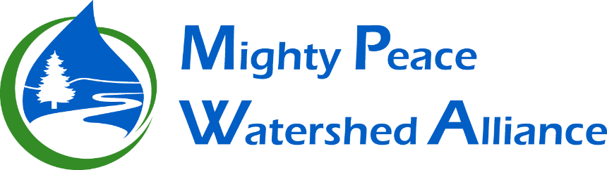

**Integrated Watershed Management Plan Steering Committee (IWMP SC)**

**Terms of Reference**

The following document describes the purpose and structure of this committee including what it plans to achieve, who will participate, how it will do its work and when it will be achieved. The Board of Directors approved these Terms of Reference on __________________________.

**Context**

The Mighty Peace Watershed Alliance Society (MPWA) is a multi-stakeholder not-for-profit organization registered under Alberta’s Society Act. The MPWA is one of several *Watershed Planning and Advisory Councils* created under Alberta’s *Water for Life* strategy. The MPWA is committed to achieving and implementing the three goals of the strategy:

* Safe, secure drinking water supply
* Healthy aquatic ecosystems
* Reliable, quality water supplies for a sustainable economy.

The implementation of these goals is guided by the vision, mission and shared values of the MPWA:

**Vision –** The Peace is a healthy, sustainable watershed that supports our social environmental and economic objectives.

**Mission –** To promote watershed excellence, the Mighty Peace Watershed Alliance will monitor cumulative effects from land use practices, industry and other activities in the watershed and work to address issues through science, education, communication policy and by supporting watershed stewardship.

**Shared Values -** The Mighty Peace Watershed Alliance will:

|  |  |
| --- | --- |
| **Respect a diversity of peoples and values** | *By demonstrating individual and collective respect for the air, land and water and by appreciating the diversity of values and opinions found in the Peace watershed.* |
| **Be an ambassador** | *By promoting our vision and mission, demonstrating integrity, accountability and practicality, and practicing effective communication, knowledge-building and consensus decision-making.* |
| **Be a trustworthy and credible source of information** | *By being well-informed and providing sound advice through an adaptive watershed approach that integrates traditional local and scientific knowledge in information-gathering and problem solving.* |
| **Be fair and transparent to all** | *By seeking balanced representation and listening to all stakeholders in an open, transparent manner.* |
| **Be inclusive and collaborative** | *By facilitating inclusive and collaborative processes and partnerships, promoting membership and interaction and providing opportunities for all stakeholders to be involved.* |
| **Be action-oriented and innovative** | *By being motivated, resourceful and action-oriented in finding new, innovative ideas and win-win strategies.* |
| **Foster stewardship** | *By encouraging and enabling individuals and organizations to be good stewards of the watershed.* |

**Committee Purpose**

Originally, this committee oversaw the development of the 2015 State of the Peace and Slave Watersheds (SOW) and the 2018 Integrated Watershed Management Plan (IWMP). However, upon completion of this task the committee was tasked by the Board of Directors with the following.

1. To review and implementation of the IWMP recommendations
2. To provide recommendations to Board on how to further implementation of the IWMP.
3. To oversee renewals, updates and iterations of the SOW.

**Objectives**

This committee will oversee an annual review of any implementation that has occurred on recommendations of the Integrated Watershed Management Plan. As recommendations in this plan were directed at decision-makers within the watershed, MPWA often has no direct influence over certain aspects of implementation. Subsequently, this committee’s work involves assessing action taken not only by MPWA but also decision-makers throughout the watershed and considering how to support other organizations in implementing the recommendations.

In following the principles of adaptive management, this committee will also oversee iterations of the State of the Watershed. The State of the Watershed measures and communicates about the current condition of the watershed and the Integrated Watershed Management plan recommends management actions based on the current condition and the desired condition of the watershed. To maintain a wholistic, integrated watershed approach, this committee will oversee both of these primary components of watershed management that MPWA is engaged in.

**Membership**

1. Membership of the Integrated Watershed Management Plan Steering Committee must be approved by the board and shall consist of the following classifications:
   * Chairman of the board (*ex officio)*
   * A non-government organization sector representative
   * A government sector representative
   * An Indigenous Communities sector representative
   * An industry sector representative
   * 2 other directors

NOTE: as per the MPWA Process Guide, the Board is compromised of Directors from 4 sectors.

1. The committee can, as it sees fit, call upon the expertise of people outside the committee and outside the MPWA.

**Meetings**

Meetings will be set as required and notification will be provided electronically.

**Reporting**

1. The IWMP SC is responsible to and reports to the MPWA board (MPWA Process Guide section 6.1).
2. A system of reporting on the implementation of the IWMP was established by the committee and approved by the board. This reporting is similar to a ‘report card’ of achievements, progression, acknowledgment of concerns or issues, and future direction.
3. This reporting will at a minimum take place annually at a regular meeting of the board.
4. Regarding SOW work, this committee will recommended approaches to State of the Watershed updates, renewals or iterations will be presented to the Board as work occurring and final approval lies with the Board. Currently, MPWA is requested to update the SOW every 8 years or as needed (Mandate and Roles Document, 2022).

**Quorum**

A simple majority of committee members shall constitute quorum.

**Delegation**

1. The IWMP SC may as needed strike Working groups. The membership of the working groups will be determined by the IWMP SC so that the required technical expertise is present (MPWA Process Guide section 6.3 & 6.4).

a. Working groups are responsible to and report to the IWMP Steering Committee.

b. Working groups are struck for a particular task and shall not continue operate beyond the completion of the task without explicit direction from the Technical Committee.

2. The IWMP SC may, as needed, engage consultants to complete tasks.

a. The consultants will be selected through an RFP process in alignment with MPWA guidelines and process.

b. The IWMP SC is responsible for overseeing and managing the consultant to ensure that the desired results are obtained.

3. The IWMP Steering Committee has the ability to delegate the completion of tasks to others

(including the Technical Committee) as needed, but responsibility is never delegated and remains with the IWMP Steering Committee.

**Timelines**

An annual review should be completed at the close of every fiscal year (April 1 – March 31).

**Appendix #1**

**The current committee as of December 5, 2024**

* + **Chairman of the board (*ex officio)* (Chris Thiessen)**
  + **A non-government organization representative (Dave Walty)**
  + **A government representative (Abdi Siad-Omar)**
  + **An Indigenous Communities representative (Alden Armstrong)**
  + **An industry representative (Wayne Thorp)**
  + **2 other Directors (Corinna Williams and Ashley Rowney).**