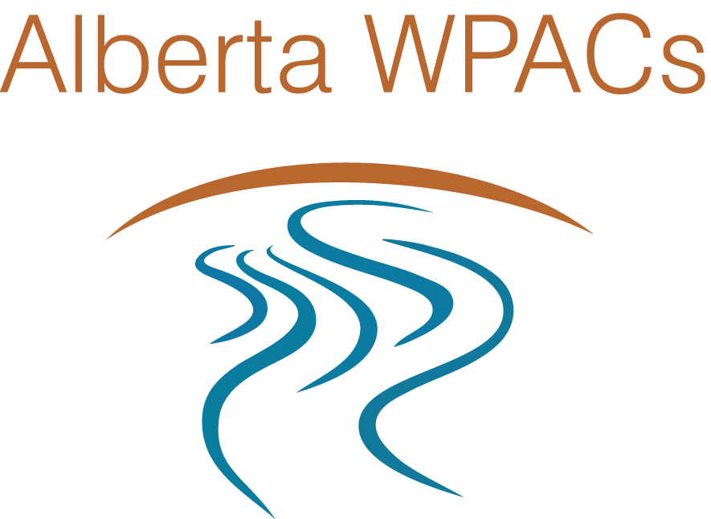

**Alberta WPACs**

**Five Year Renewable**

**Memorandum of Understanding**

**January 2022**

**Preamble**

Alberta’s Watershed Planning and Advisory Councils (Alberta WPACs) actively engage governments, industry, non-government organizations, Indigenous Peoples, and the public in education, watershed assessment, restoration, planning, monitoring, and in provincial watershed management, and conservation. Alberta WPACs are committed to pursuing the goals of ***Alberta’s Water For Life Strategy*** and continue to work through knowledge and research, partnerships, provide advice on water and watershed management, and collaboration to address new challenges impacting Alberta’s watersheds. Eleven Alberta WPACs are operating, and cover over 90% of Alberta’s land and water base within their boundaries

The revised *Memorandum of Understanding* between all Alberta WPACs defines the benefits of working collaboratively, the relationship between the eleven individual WPACs, and renews the commitment to the overarching Alberta WPACs collaborative initiative. The original MOU was established in 2012.

Working collaboratively creates several significant benefits for WPACs. It will increase our visibility to the public, indigenous groups, and government agencies, help us align with funding priorities, strengthen other partnerships, and can lead to overall organizational effectiveness and efficiency.



**Memorandum of Understanding – Statement of Purpose**

The eleven WPACs of Alberta agree to work together as a collaborative, hereafter referred to as **Alberta WPACs** (Alberta Watershed Planning and Advisory Councils)in order to:

1. Strengthen a working Alberta WPACs collaborative to efficiently address province-wide watershed management issues, as agreed upon through consensus by all Alberta WPACs;
2. Improve our collaborative partnership with Alberta Environment and Parks; and
3. Address critical issues of collective importance and collaboratively develop and express shared views on these key concerns.

To accomplish these three key directions, Alberta WPACs agree to:

* Explore opportunities to develop shared communications and marketing materials in support of the WPAC collective, as well as supporting awareness about watershed management and water literacy.
* Share knowledge and information on the WPAC management and administrative functions of mutual interest, including but not limited to: human resources; legal services; communications; corporate policies; watershed awareness and education materials; and Board development.
* Explore opportunities and develop collaborative initiatives on regional, provincial, and national projects of mutual interest.

**Decision-Making Process**

Decisions will be made through approved collaborative processes, working in concert with WPAC Managers and Boards.



**Roles and Responsibilities of the Individual Watershed Planning and Advisory Councils**

Each member WPAC of the eleven Alberta WPACs agrees to:

* Meet quarterly and attend the biennial WPAC Summit Conference, to further the goals and objectives of the Alberta WPACs initiative;
* Provide input to annual goals and initiatives for the Alberta WPACs collaborative initiative;
* Support and communicate the Alberta WPACs collaborative initiative in their watershed;
* Provide in-kind support (as required and available) for key Alberta WPACs initiatives as a part of core WPAC operations;
* Request in-kind contributions from key stakeholders and funders to support Alberta WPACs goals and initiatives;
* Support the initiatives of WPAC Committees to the best of their ability.

**Voluntary Disassociation**

This Memorandum of Understanding is a nonbinding agreement that all parties have entered into, in good faith. Any party may disassociate from the Alberta WPACs collaborative initiative through written notice sent sixty (60) days prior to the disassociation.

Though some WPACs may not sign the MOU, they are still part of the Alberta WPAC collective and should participate in the fullest of their ability as possible.

**Term and Amendment**

This revised MOU shall be in effect beginning April 1, 2022. This MOU represents the entire understanding of all parties with respect to the Alberta WPACs collaborative initiative. Any modification of this MOU must be in writing and signed by all parties.



_____________________________________ ____________________________________

Dan Moore, Chair Petra Rowell, Executive Director

Athabasca Watershed Council Athabasca Watershed Council

_____________________________________ ____________________________________

Ryley Anderson, Co-Chair David Samm, General Manager

Battle River Watershed Alliance Battle River Watershed Alliance

_____________________________________

Alan Corbett, Co-Chair

Battle River Watershed Alliance

_____________________________________ ____________________________________

Erwin Braun Chair Mike Murray, Executive Director

Bow River Basin Council Bow River Basin Council



_____________________________________ ____________________________________

Amanda Avery-Bibo, Chair Kristina Morris, Executive Director

Lakeland Industry and Community Lakeland Industry and Community

Association Association

______________________________________ ___________________________________

Todd Bailey, Chair Meghan Payne, Executive Director

Lesser Slave Watershed Council Lesser Slave Watershed Council

______________________________________ ___________________________________

Rick Keillor, Chair Rhonda Clarke-Gauthier, Executive Director

Mighty Peace Watershed Alliance Mighty Peace Watershed Alliance

______________________________________ ___________________________________

John A. Ross,Chair Tim Romanow, Executive Director

Milk River Watershed Council Canada Milk River Watershed Council Canada



_____________________________________ ___________________________________

Ken Crutchfield, Chair Leak Kongsrude, Executive Director

North Saskatchewan Watershed Alliance North Saskatchewan Watershed Alliance

______________________________________ ___________________________________

Doug Kaupp, Chair Shannon Frank, Executive Director

Oldman Watershed Council Oldman Watershed Council

______________________________________ __________________________________

Kent Dyck, Chair Josée Méthot, Executive Director

Red Deer River Watershed Alliance Red Deer River Watershed Alliance

______________________________________ __________________________________

Ryan Davison, Chair Marilou Montemayor, Executive Director

South East Alberta Watershed Alliance South East Alberta Watershed Alliance